Music and Math
Pitch is the perception of a frequency. Each note on the scale has a different frequency. Look at how musical notes are related to frequency.

Avatar: Perfect Pitch

Frequency
Dakota: Do you have perfect pitch? Not a pitch as in baseball, but pitch as in sound. This is a talent where someone can recreate sounds perfectly. Given a named note, a person with perfect pitch can sing that note perfectly without the aid of an instrument. Some people are able to sing in specific keys on command. But what makes one note different from another? How is a B flat different from an F sharp? Each note on the scale has a different frequency. A person with perfect pitch is able to match those frequencies exactly.

Wave Words
See what you remember about the important words related to waves, as well as what pitch and the speed of sound are.

Galleria

Wavelength

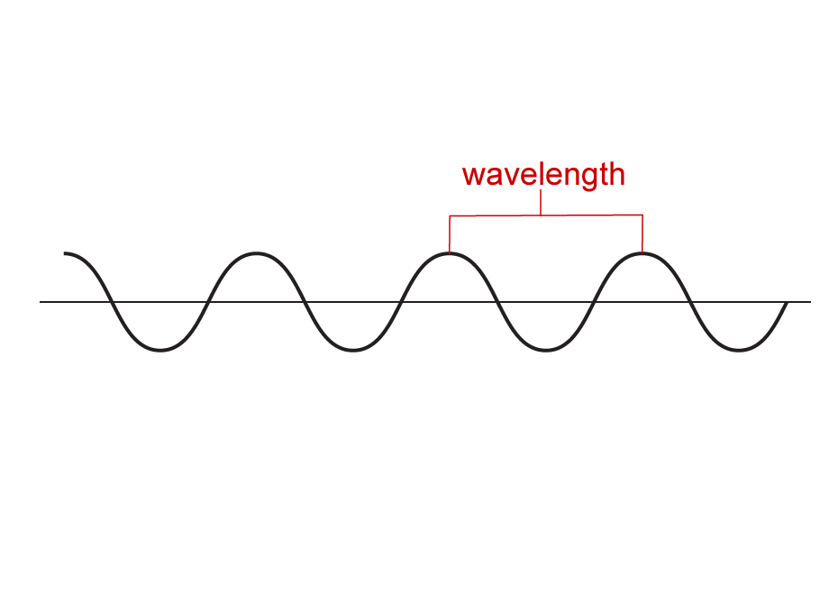
Diagram of a wave with the wavelength labeled

The wavelength is the distance it takes to complete one cycle of a wave. It is a measure of length with the units typically being meters. The wavelength is inversely proportional to the frequency of a wave.

Frequency


Diagram of various waves with different frequencies

The frequency is the number of waves that pass a given point per second. The units for frequency are per second or hertz (Hz). Musical instruments change the frequency to change the note.

Pitch


Photograph of a person singing

The pitch is the perception of the frequency of a sound wave. Higher frequencies produce higher pitched sounds. Lower frequencies produce lower pitched sound.

Amplitude

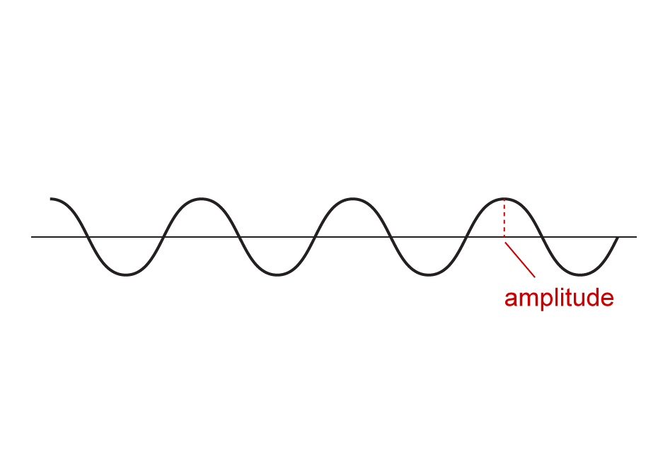

Diagram of a wave with the amplitude labeled

The amplitude is the height of the wave. It is a measurement between the rest position and the crest of the wave. Amplitude is responsible for the loudness of the sound.

Speed of sound


Photograph of a speedometer

The speed of sound is just the wave speed for sound. Wave speed is the number of cycles of a wave that occur in a given time period. The wave speed of sound in air is 343 m/s.

Frequency and Pitch
The speed of a sound wave can be related to the pitch through frequency. The speed of sound in air is 343 m/s. Pitch is the perception of a frequency. The relationship between frequency and wave speed is found in the equation:
v =fλ
v - wave speed (m/s)
f - frequency of the wave (Hz)
λ - wavelength (m)
The speed of the wave is directly related to the frequency. This means that if the frequency increases, the wave speed will increase as well. The frequency and wavelength have an inverse relationship. Since the speed of sound in air remains constant, an increase in pitch or frequency causes the wavelength to decrease.

Working a Wave Problem
Try to memorize that the speed of sound in air is 343 m/s. That piece of information will help you as you check out the step-by-step process of solving a sound wave problem.

Example Problem: How to Do Sound Waves Math

Directions: View each step below in the example problem.

Set up problem
Identify which quantities in the equation are given, such as the wave speed, frequency, and wavelength. When solving for pitch, you must determine the frequency.

A police siren has a wavelength of 0.50 m and travels at the speed of sound of 343 m/s. Determine the pitch of the police siren.

Check units
Make sure that the wave speed is in meters per second and that the wavelength is in meters.

Wavelength is 0.50 m.
Speed of sound is 343 m/s.

Solve problem
To solve for the frequency, divide the wave speed by the wavelength. This will yield an answer in hertz.

Frequency = 686 Hz

Assignment: Sound Waves Math Exploration
Pitch and the speed of sound are related by frequency. Practice solving some problems involving wavelength, frequency, and the speed of sound.

